DML Commands – INSERT, SELECT

Questions:

- Populate all the five tables with your own data.

course
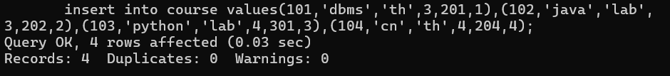
Department
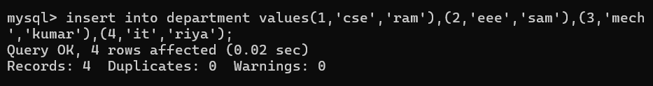
Students
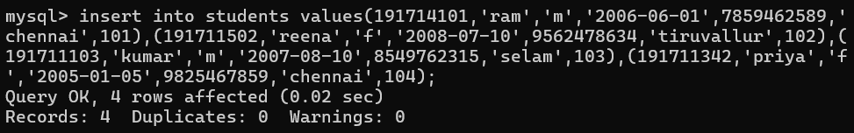
Faculty
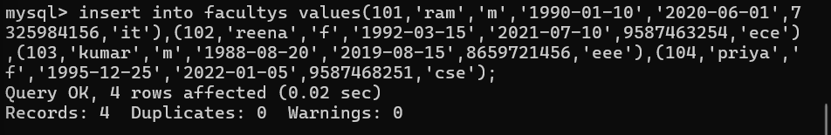

2. View all the records from the five tables.
course
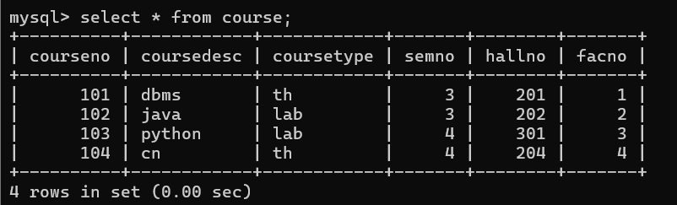
Department
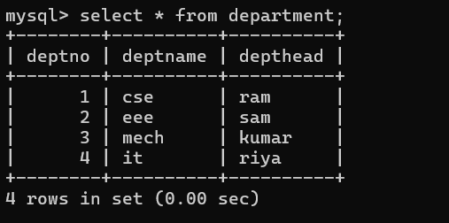
Students
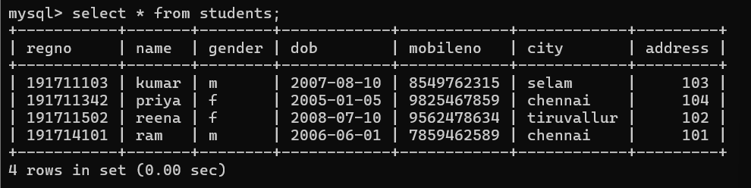

Faculty
